**ASSIGNMENT 2**

6. Delete all files in family subdirectory.

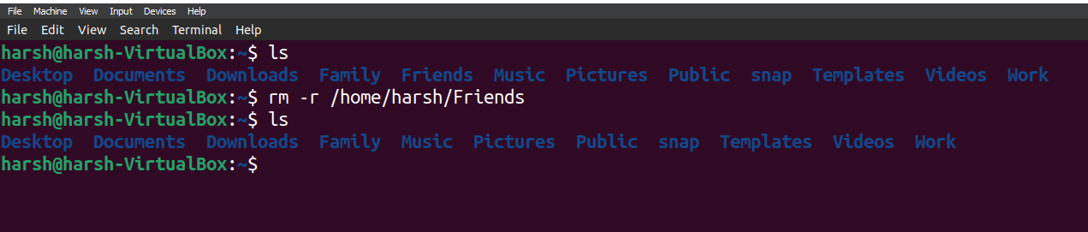

7. Delete friends subdirectory

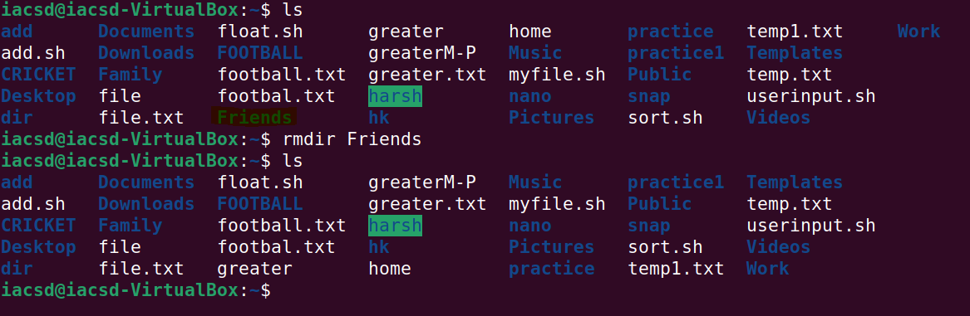

8. Create user tom , bob , sam , prince

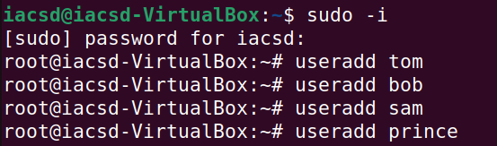

9. Create Group dac , dbda ,ditiss

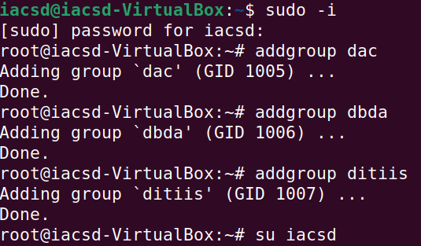

10. add user

Tom in dac

Bob in dbda

Sam in ditiss

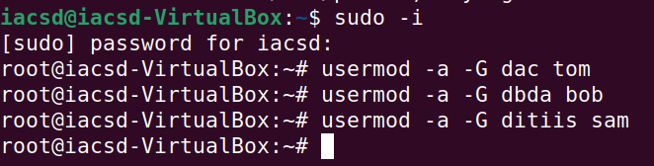

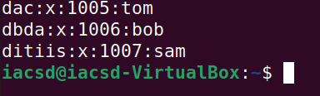

11. login as prince and create iacsd directory in /tmp and create 4 files in iacsd with name project-1 project-2 upto 4.

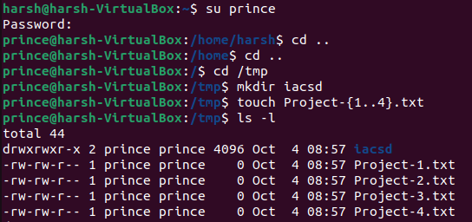

12. assign permissions to project files as below

Project-1 – tom should be owner of this

Project-2 – dac should be owner of this

Project-3 --- others should not have any permission but tom should have rw access

Project-4 – dbda group should have rwx permissions.

